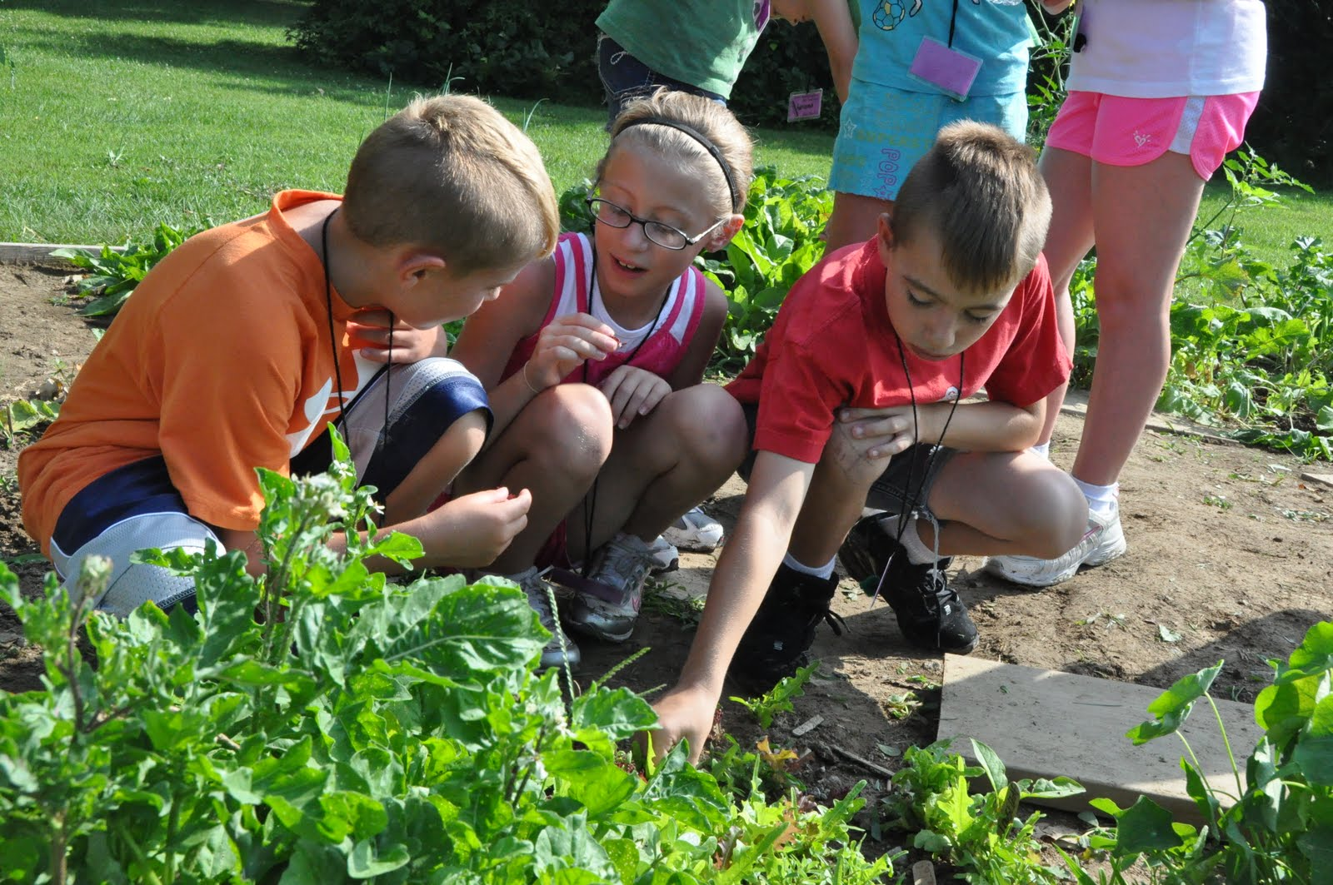

**Montessori Summer Camp**

**2019**

**Ages 6 weeks – 12 years**

**(special services for children who are deaf/hoh)**

* **June 3-7 ~ KITCHEN & Planting SURPRISES**
* **June 10-14 ~ ARTS & CRAFTS**
* **June 17-21 ~YOGA**
* **June 24-28 ~ DANCE & ZUMBA**
* **July 1-3 WATER, WATER, WATER**
* **July 8-12 ~ EXOTIC ANIMALS**
* **July 15-19 ~ BICYCLE SAFETY & SPORTS SPORTS & MORE SPORTS**
* **July 22-26 ~ SCIENCE IS MAGICAL**
* **July 29-August 2 ~ THEATER ARTS & THE ART OF FACE PAINTING**
* **August 5-9 GARDEN HARVEST**

***Rates: $250.00 per week***

***Ages 3 – 12***

***Infants/Toddlers separate fee***

**AGBMS Summer Camp provides the right instruction, equipment and the facilities to enhance their sports abilities, their artistic talents, and their adventure skills. The sheer variety of activities offered at camp makes it easy for kids to discover and develop what they like to do.**

[**WWW.AGBMS.ORG**](http://WWW.AGBMS.ORG)

**(847)850-5490**

* **CAMP IS ACTION**
* **CAMP TEACHES CHILDREN THAT THEY CAN!**
* **CAMP HELPS CONQUER FEARS**
* **CAMP EXPANDS EVERY CHILD’S ABILITIES**
* **CAMP ALLOWS CHILDREN TO DEVELOP WHO THEY ARE**
* **CAMP BUILDS TEAMWORK**
* **CAMP GETS EVERYONE OUTSIDE!**
* **CAMP CREATES FRIENDSHIPS**

**Summer camp is a great way for children to spend their day**

**being physically active!.**

**Alexander Graham Bell Montessori ~**

**9300 CAPITOL DRIVE ~ WHEELING, IL 60090**