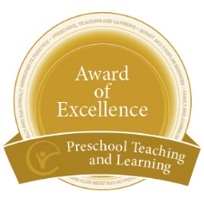
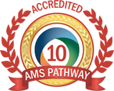

The Alexander Graham Bell Montessori School

Open House
Wednesday, February 6, 2019
4:30 – 7:00 p.m.

Refreshments Provided

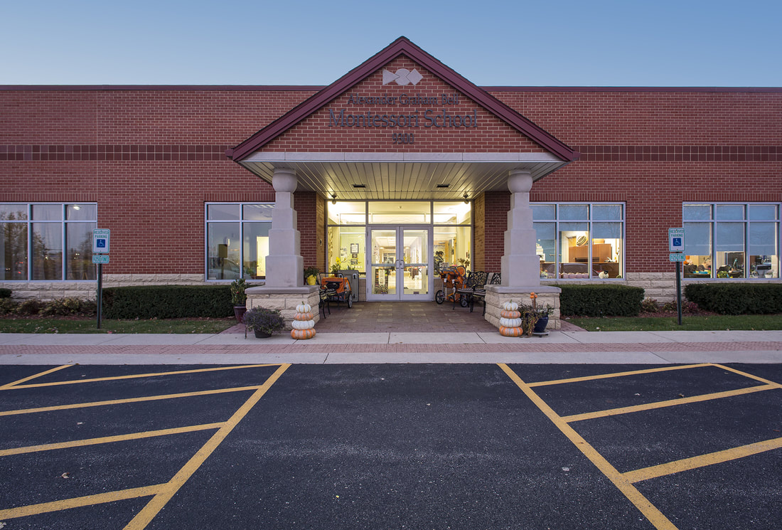

SUMMER CAMPS ~ INFANT/TODDLER PROGRAMS ~ PRE-K ~ ELEMENTARY ~ MIDDLE SCHOOL

