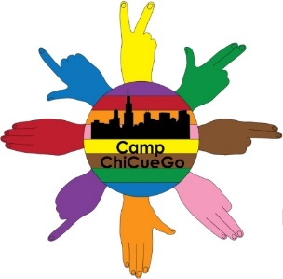
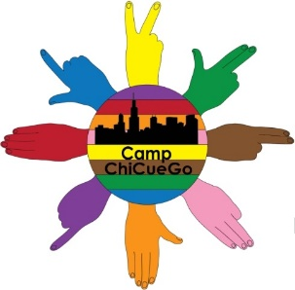
CAMP CHI-CUE-GO REGISTRATION
July 20-22, 2017
Illinois School for the Deaf
125 Webster Ave, Jacksonville, IL 62650
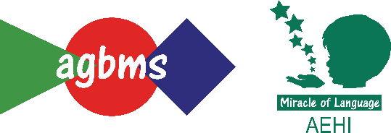
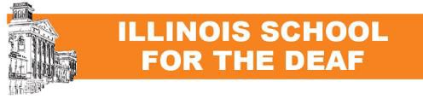

Family Name | Address | City, State, Zip
Email | Phone | Phone
Would you like more information about membership with the NCSA (National Cued Speech Association)? Yes No

First & Last Name | If child, Age/  Grade Level | If D/HH, amplification and communication modality | Cued Speech workshop level (Level 1, Level 2, Level 3, youth/teen, child OR unsure) | Accommodations needed? (communication, dietary, etc.) | Are you a family member, educator, or professional?
Fees** (includes meals, snacks, and materials): REGISTERING AFTER JULY 1st? ADD $25 FOR LATE REGISTRATION!
Individuals | $150 |  | If paying by credit card: Mastercard Visa Discover (circle one)
Family of 2 or 3 | $200 |  | Card #
Family of 4 | $250 |  | Expiration Date: | Signature:
Family of 5+ | $300 |  | Security Code:
 | Total |  | Billing Zip Code:
**Fees are non-refundable. We accept credit cards, checks, and money orders. Please register multiple families separately. Thanks!
Checks/money orders can be made payable to AGBMS-AEHI. Registration form should be sent to AGBMS-AEHI, 9300 Capitol Dr., Wheeling, IL 60090 or faxed to 847-850-5493. You may also call in your registration at 847-850-5490 or email it to karla.giese@agbms.org.
Online registration and payment with credit card/PayPal is available at www.agbms.org/camp-chi-cue-go-2017.html
Questions? Contact Karla Giese at karla.giese@agbms.org or call 847-850-5490.

